

Simulation of MPLS Label Description Protocol using GNS3

CLASS: REPORT



April 10, 2017

Submitted By: Kriti Walia & SHIVANG VIKRAM SINGH

SUBMITTED TO: PROF. NADER MIR, PROFESSOR

## Group Members:

* Kriti Walia
* Shivang Vikram Singh

## **Simulation of MPLS LDP:**

We followed the directions provided by Dr. Nader Mir, to install and configure GNS3 on our laptop devices. Once configured, we started the project by configuring images of four routers namely, R1, R2, R3, and R4 as shown in the image below:

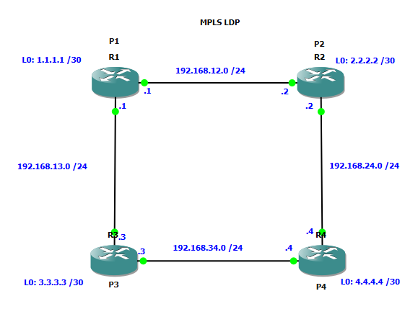

Figure A: Routers Image in GNS3: R1, R2, R3, & R4

## Set-up description in GNS3:

Each router is assigned a Router id and label as shown in the figure A. It is also visible from our configuration that Router R1 is connected to R2 and R3; router R2 is connected to R4 and R1; router R3 is connected to R1 and R4; and router R4 is connected to R3 and R2. Each interface of the router has its own IP address and there are two interfaces for each router.

In this Model, OSPF is configured in each router. This is done by importing the configurations given in the module. There are several commands used in this simulation, which is discussed later in the report.

With MPLS forwarding, when a packet arrives at a router, the router looks at the incoming label, it looks up the label in a table and then forwards the packet to the next hop.

When you enable MPLS LDP, the LSRs send out messages to try to find out other LSRs with which they can create LDP sessions. There are two type of LDP sessions: 1) directly connected sessions and 2) indirectly connected sessions.

The main purpose of this is to show how MPLS LDP works and how labels are assigned between each pair of attached LSR.

## **MPLS and LDP Description:**

Multiprotocol Label Switching (MPLS) Label Distribution Protocol (LDP) enables peer label switch routers (LSRs) in an MPLS network to exchange label binding information for supporting hop-by-hop forwarding in an MPLS network.

MPLS LDP provide the means for LSRs to request, distribute, and release label prefix binding information to peer routers in a network enables LSRs to discover potential peers and to establish LDP sessions with those peers for exchanging label binding information.

MPLS LDP enables one LSR to inform another LSR of the label bindings it has made. Once a pair of routers communicate the LDP parameters, they establish a label-switched path (LSP). MPLS LDP enables LSRs to distribute labels along normally routed paths to support MPLS forwarding. This method of label distribution is also known as *“hop-by-hop forwarding”*. One of the application that use hop-by-hop forwarding is MPLS VPNs.

LDP provides a standard for hop-by-hop or dynamic label, distribution in an MPLS network by assigning labels to routes that have been chosen by the underlying IGP routing protocol. The resulting labeled paths are called label switch paths, forward label traffic across an MPLS backbone to destinations. LDP is a superset of the Cisco pre-standard Tag Distribution Protocol, which supports MPLS forwarding along normally routed paths.

To initiatean LDP session between routers, the routers determine which router will take the active role and which will take the passive role. The router takes the active role and establishes the LDP TCP connection session and initiates the negotiation of the LDP session parameters.to determine the roles, the two routers compare their transport addresses. The router with higher IP addresses take the active role and establishes the session. LSR can be configured to respond to the requests for the targeted Hello messages by issuing the mpls ldp discovery-hello accept command. The active LSR mandates the protocol that is used for a targeted session. The passive LSR uses the protocol of the received targeted Hello messages.

The label used in a label binding is allocated from a set of possible labels is called **label space.** Label bindings is an association between a destination prefix and a label.LDP supports two types of label spaces: Interface-specific and Platform-wide. LDP ID takes <LDP router ID>: <Local label space ID>

## **Project Step 1:**

In this step, we configured R2, R3, and R4 to activate MPLS Protocol as shown in the image below.

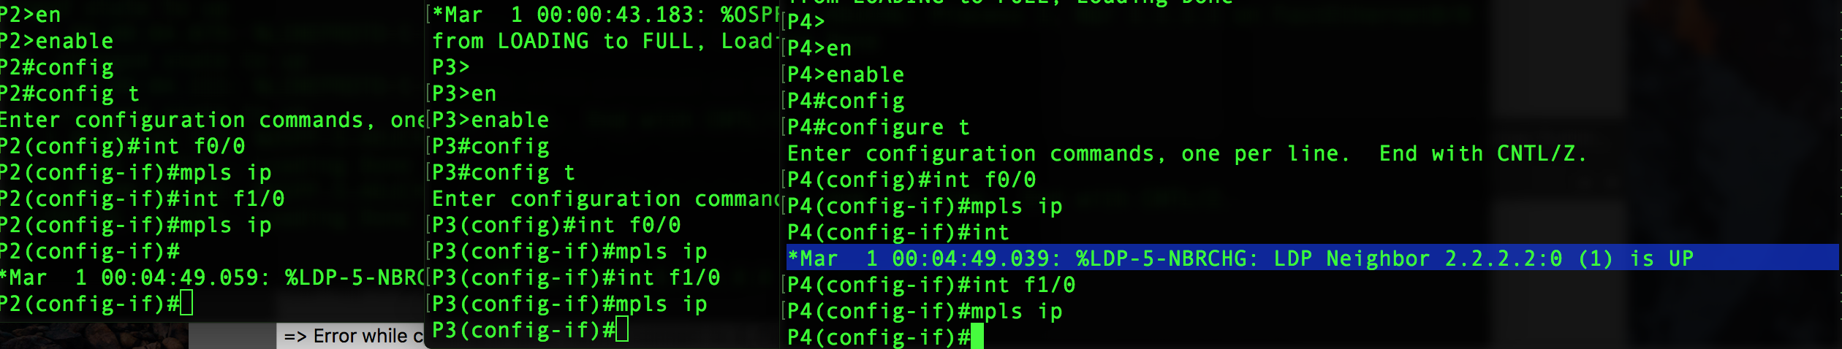

Figure 1: Activating MPLS Protocol Screenshot

In this step, firstly, we use **enable** to enable the privileged EXEC mode and then we enter the global configuration mode by using **configure terminal** and then specifies the terminal to be configured (ex: F0/0) and enters the interface configuration mode using **interface F0/0**(ex). Lastly, we used **MPLS IP** to configure MPLS hop-by-hop forwarding globally**.**

The highlighted line indicates that the neighbor i.e. R2 is up and successfully configured; and hello messages are exchanged between them. Label binding is also done between them.

## **Project Step 2:**

We configured router R1 to enable MPLS protocol using **tag-switching IP.**

In this step, we enable the privileges and then enter into configuration mode by using **configure terminal**, which specifies the terminal to be configured using interface F0/0. Then we use **tag-switching IP** which is another command, similar to MPLS IP, which is used to configure MPLS hop-by-hop forwarding globally. Basically, both commands are same. To support backward compatibility, the tag-switching form of the command is written to the saved configuration. At last, used the do show run will show the running configuration of the router R1.

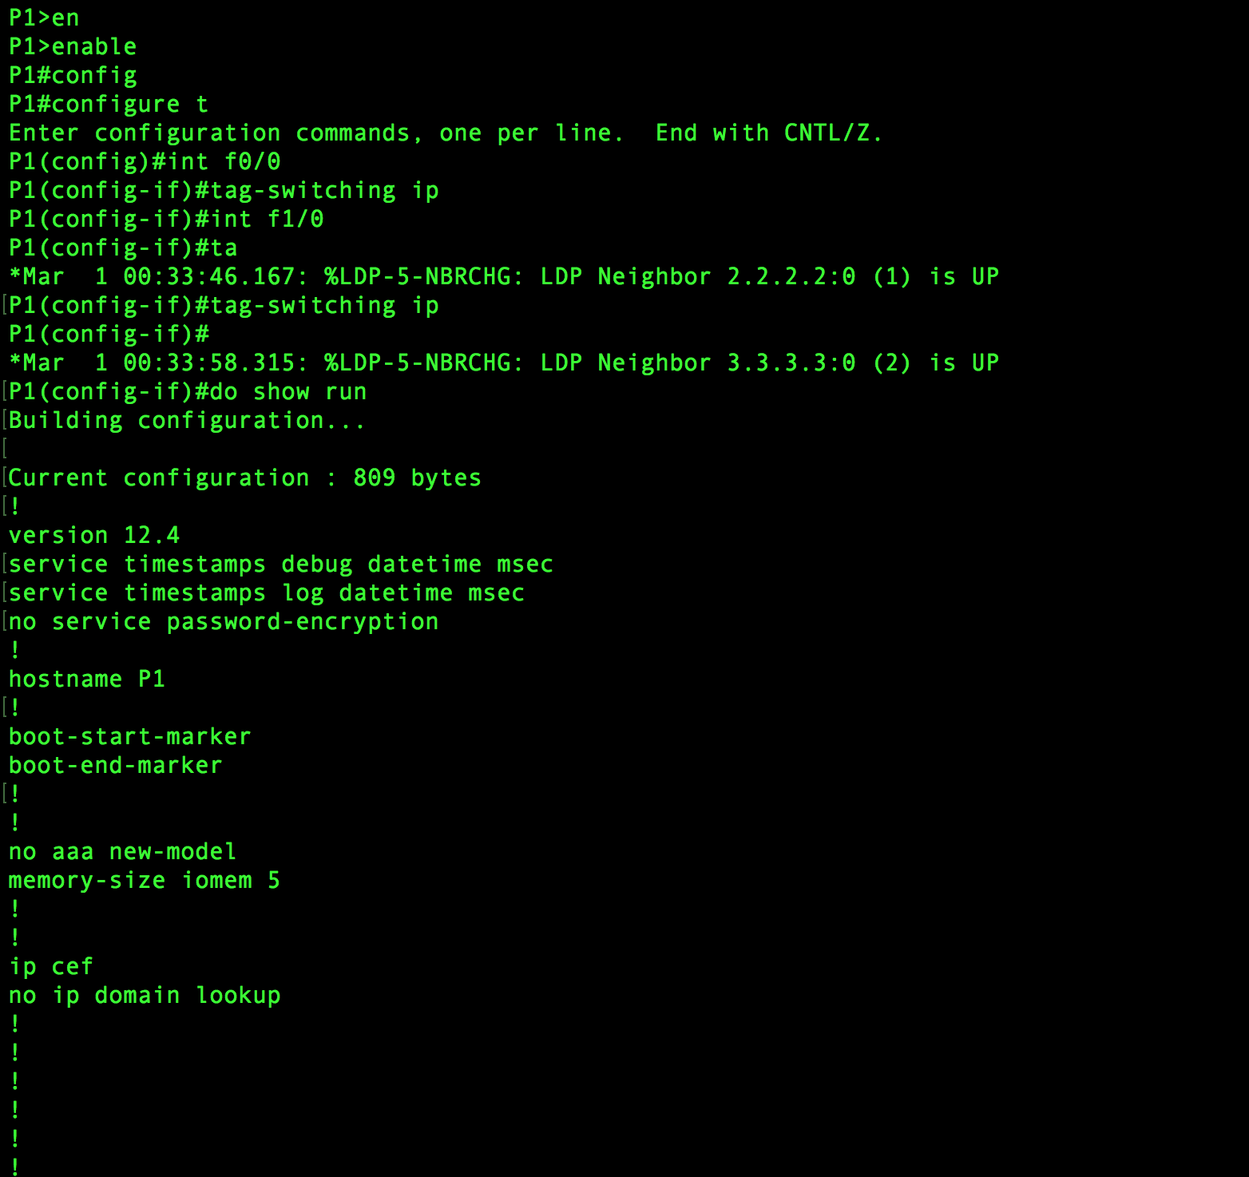Figure 2-A: MPLS Protocol Screenshot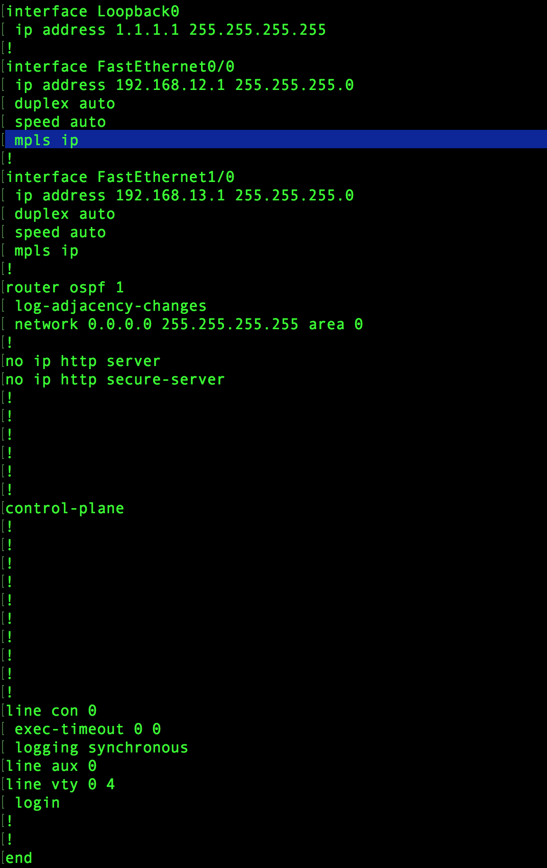

Figure 2-B: MPLS Protocol Screenshot-continued

In the screenshot above, loopback addresses and the interface addresses are shown. It also specifies the MPLS IP with the router OSPF 1 and its area.

## **Project Step 3:**

In this step, we configure all routers. Label range 20-200 is used. In R1, we used command **MPLS label range 20 200** which will fix the range of the MPLS.

**The default MPLS label range for cisco router 3640 used in the topology is <16-1048575>.**

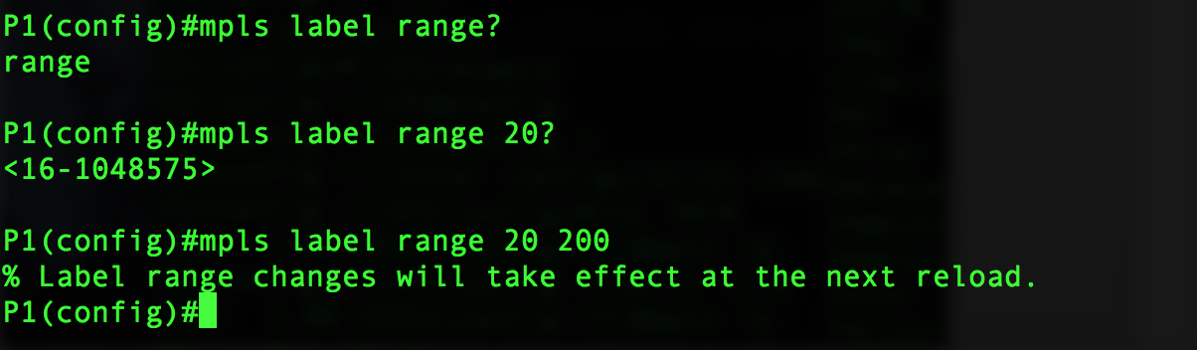

Figure 3-A: MPLS Label – P1

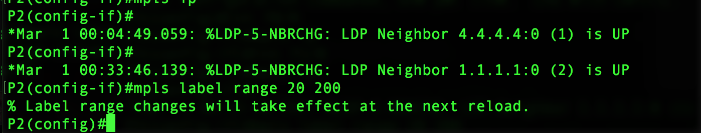

Figure 3-B: MPLS Label-P2 - Continued

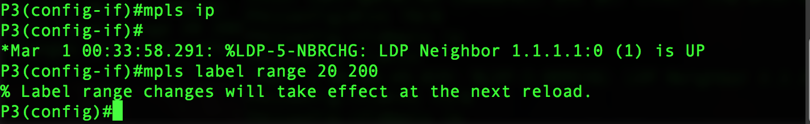

Figure 3-C: MPLS Label- P3 - Continued

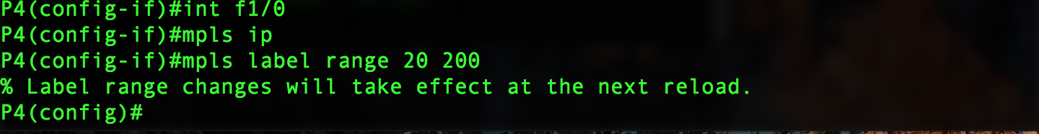

Figure 3-D: MPLS Label- P4 - Continued

We applied similar approach to this to all the routers, i.e., we limit the MPLS label range.

## **Project Step 4:**

We configured the router R1/P1 to use the IP address on the F0/0 interface as MPLS Router- ID and we configured router R2 also.

In this step, we run the command **show MPLS LDP neighbor on router R2.** It will tell information about the neighbor.

This will display the status of LDP sessions. In this, router R2 is sending and receiving messages from R4. It specifies the Router ID and interface in which router is connected and specifies the source and destination IP address.

Similarly, Router R2 is sending and receiving information from router R1.

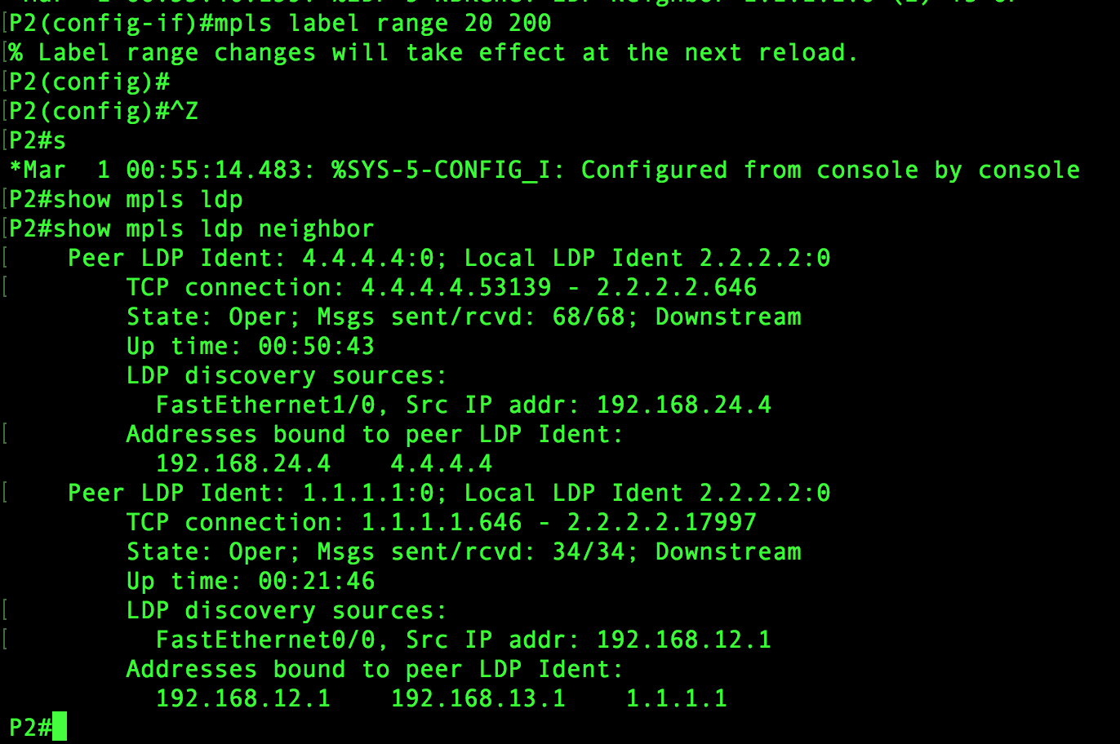

Figure 4-A: Router R2 Sending/Receiving Information

The above screenshot provide all the information about router R2 and its neighbor. It gives us the information about the router id of the neighbor and the addresses of source and destination. It also tells us about the LDP discovery recourses and address bound to the peer LDP Identity. The router R2 has two neighbors namely R4 and R1.

In router R1, we use the command **MPLS LDP router-id fastEthernet 0/0 force:**

This will forcibly change the LDP router ID. It will alter the behavior of the MPLS LDP router id command.

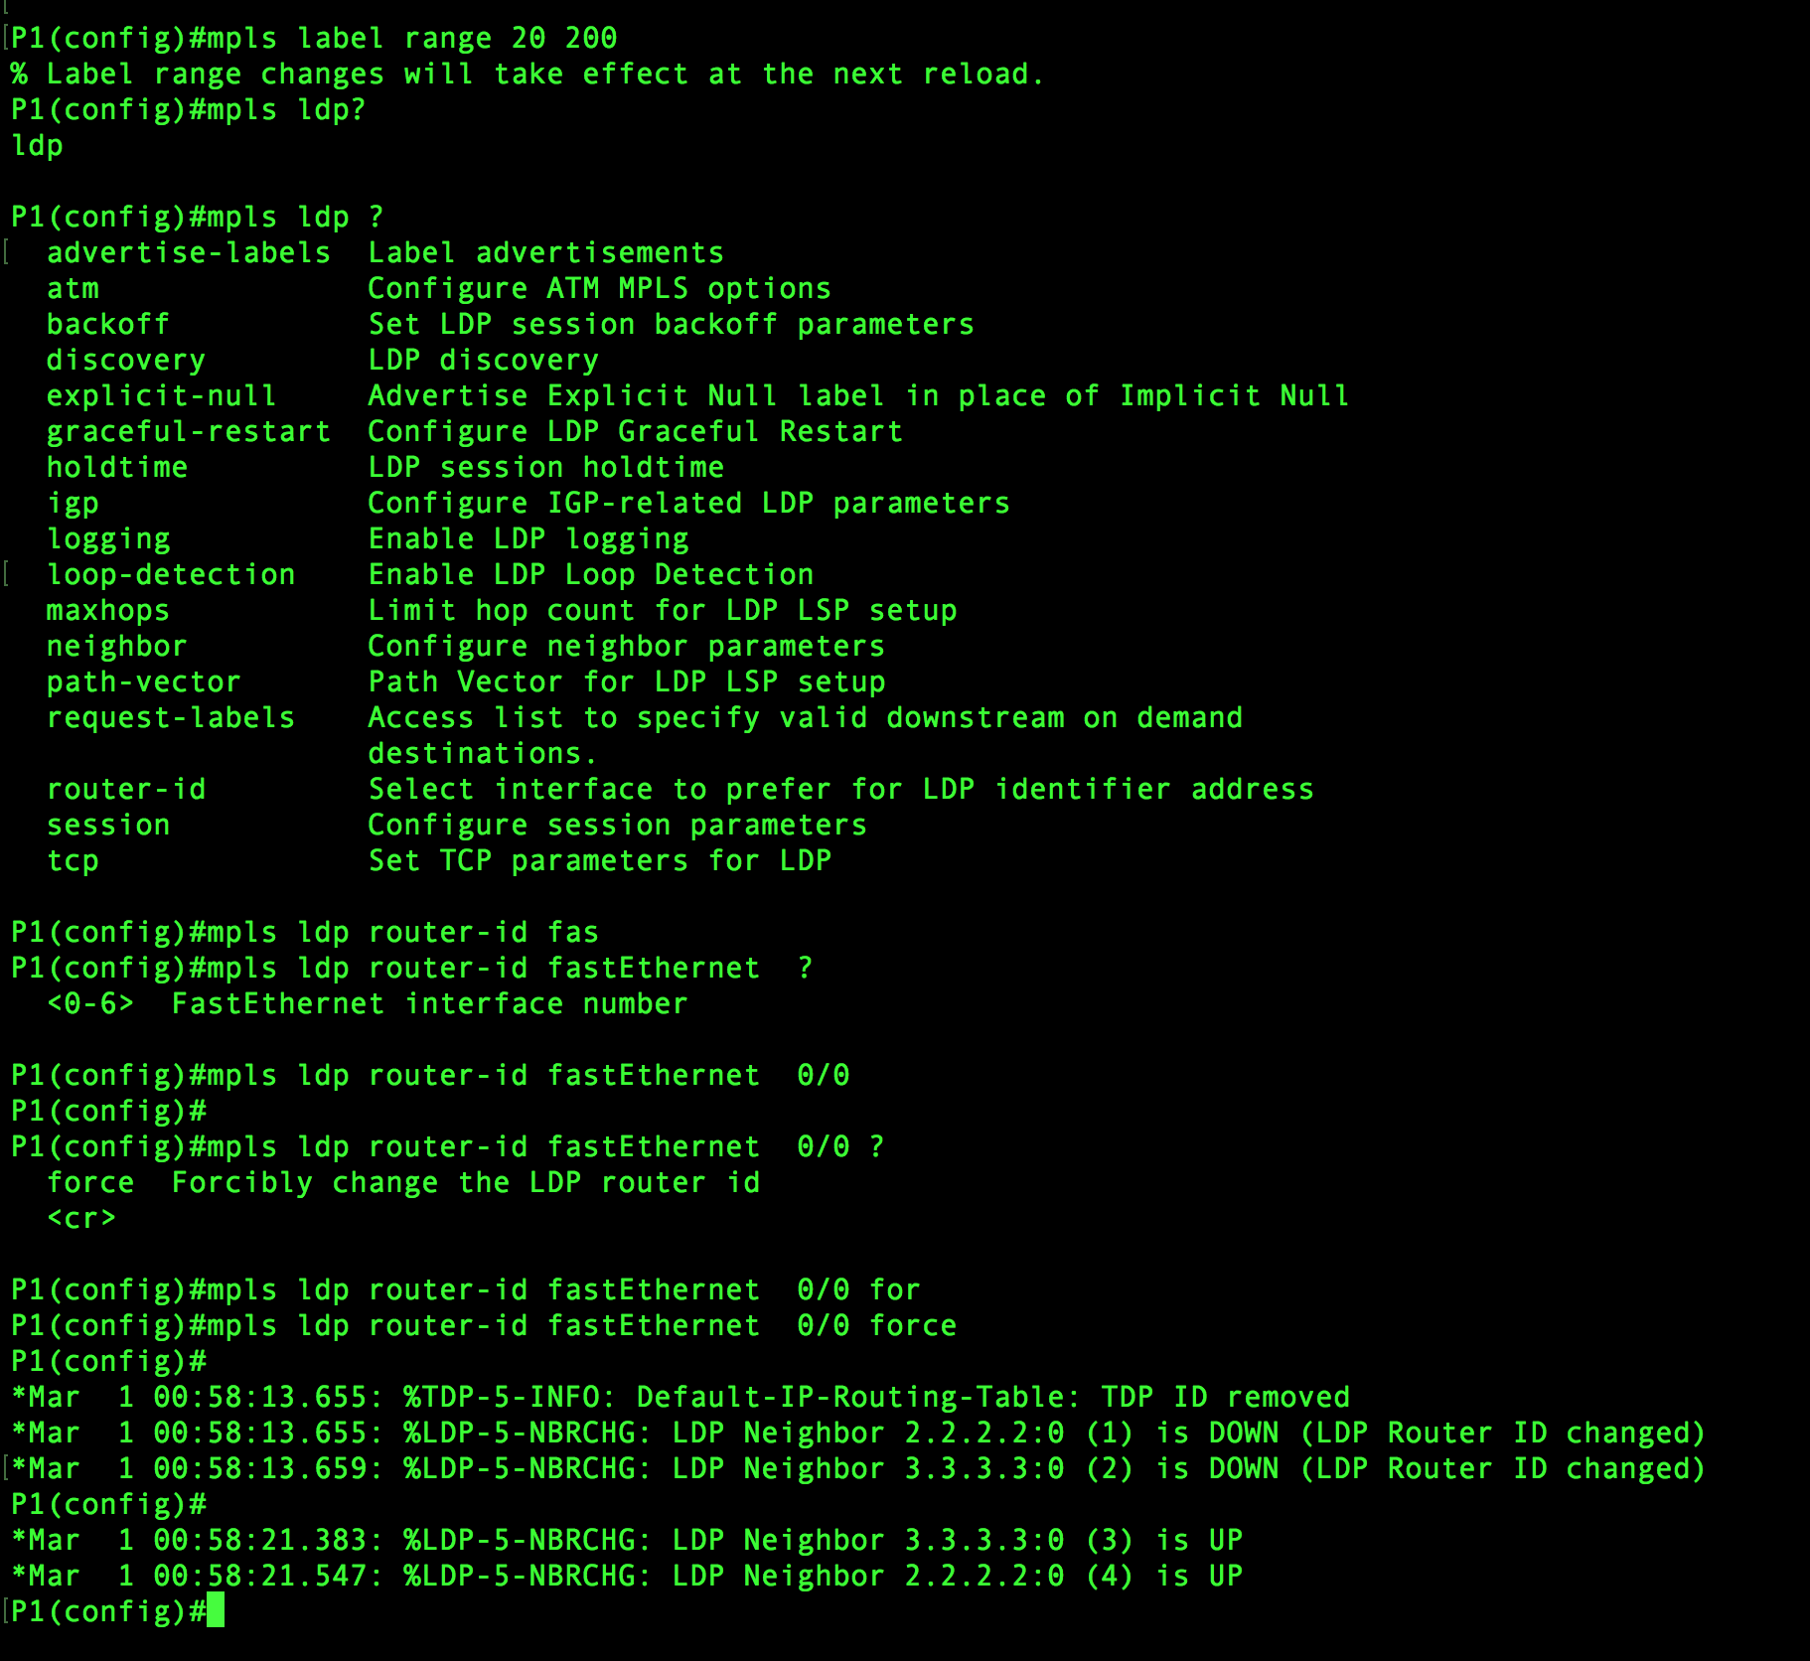

Figure 4-B: Router R1 Sending/Receiving Information

In this screenshot, we can see that the LDP neighbor’s id is changed. Example: 3.3.3.3:0 the first four bytes is the router id and last one is label space ID.

After the changes in R1, we can see the changes in P2. We can see the neighbor id changed.

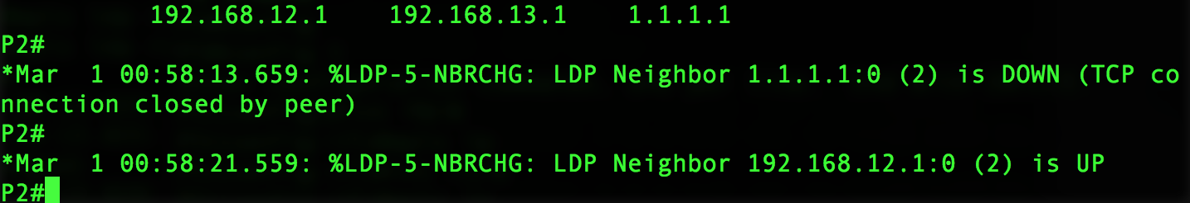

Figure 4-C: Changes in P2

## **Project Step 5:**

We configure all routers to send the MPLS hello every 2 seconds, the hold time should be 10 seconds.

In this step, we use **MPLS LDP discovery hello interval 2** and **MPLS LDP discovery hello hold time 10**.

This will set the hello interval for only 2 second from the range of <1-65535> and similarly it will also set the hold time for 10 seconds from the range of <1-65535>.

We set the same commands for all routers terminal. This will set the range for hello hold time and hello interval for all four routers.

Another command that was used in this step is do show run | incl disco will show the changes which were made using MPLS LDP discovery hello interval and hold time are successfully done.

**Do show run | incl disco screenshot:**

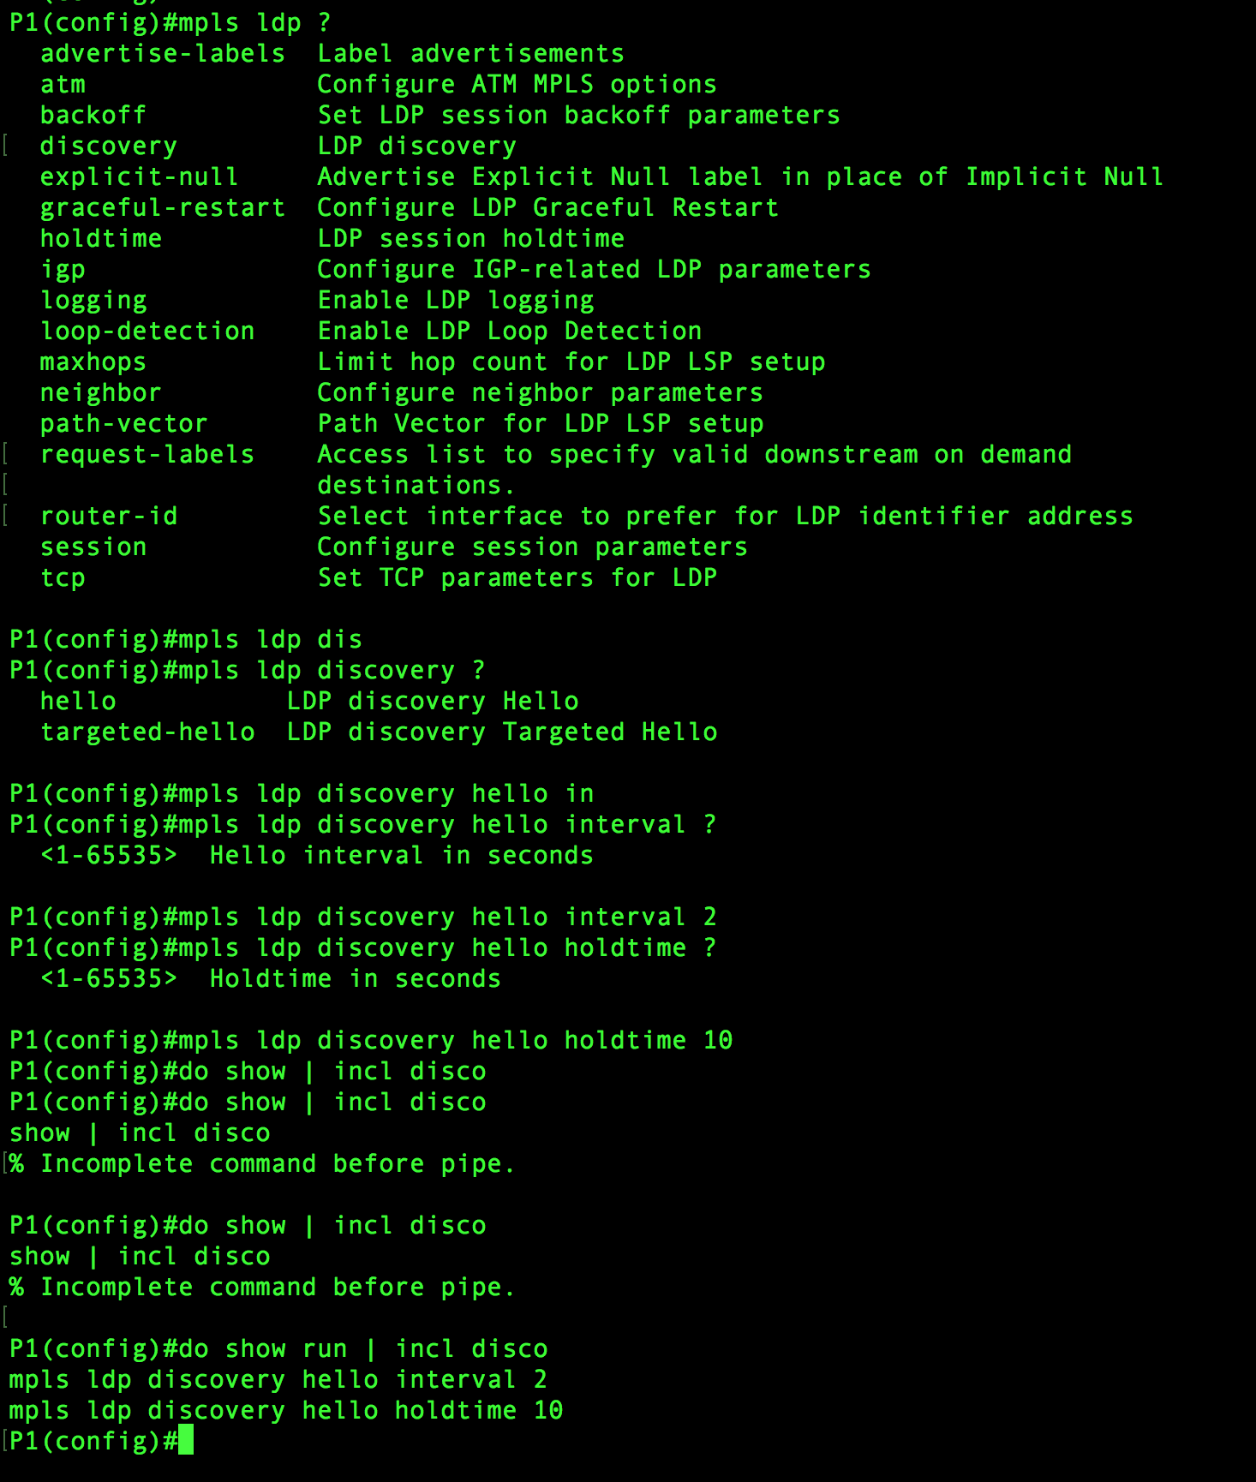

Figure 5-A: P1, Do Show Run Screenshot

**The range for MPLS LDP hello interval is: <1-65535>**

**The range for MPLS LDP hello hold time is: <1-65535>**

Similarly, we type the command MPLS LDP discovery hello interval 2 and MPLS LDP discovery hello hold time 10 in R2, R3, R4.

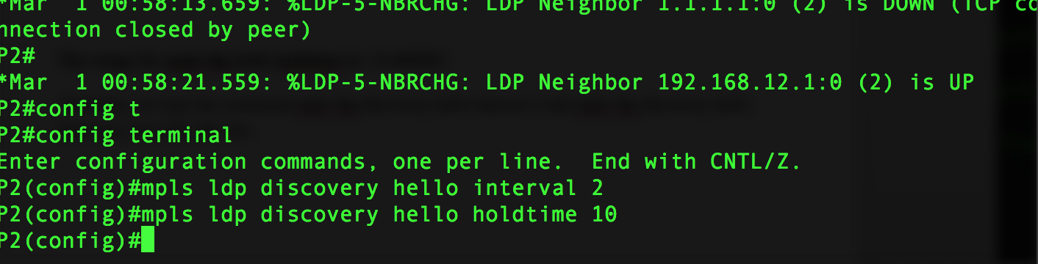

Figure 5-B: P2, MPLS LDP Screenshot

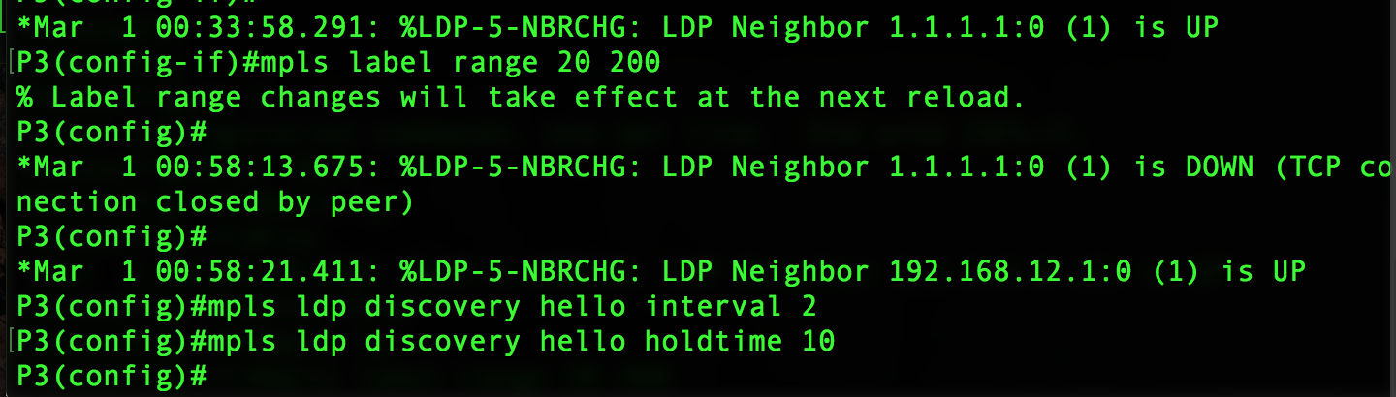

Figure 5-C: P3, MPLS LDP Screenshot

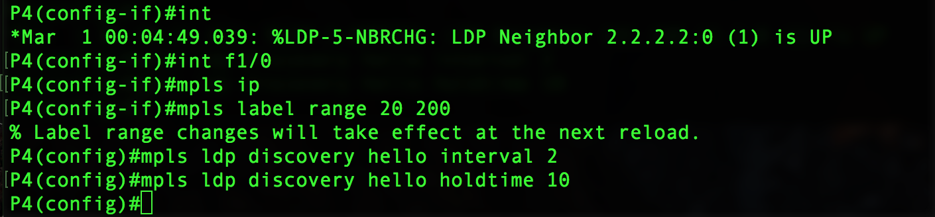

Figure 5-D: P4, MPLS LDP Screenshot

## **Project Step 6:**

We configure router R3 and R4 to establish LDP connection between their fast ethernet interfaces.

In this step, we use commands like **show MPLS LDP neighbor** in router R4 which will tell all the details of R4 and its neighbors. It will tell the router id of peer and local LDP Ident and identifies the LDP discovery sources like interface and source IP address. Also, it will tell us about addresses bound to peer LDP ident.

The second command we used is **show IP int brief** in router R4. This command will give us the description about the interfaces, IP-address, status, method, protocol. Also, it gives us the loopback address.

Screenshot for show MPLS LDP neighbor:

It gives the explanation about the router R4 neighbors.

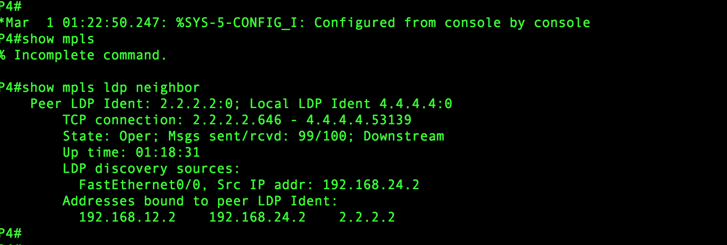

Figure 6-A: P4, MPLS LDP Neighbors

Screenshot for show IP int brief:

This screenshot gives the brief information about interfaces, IP-address, method etc.

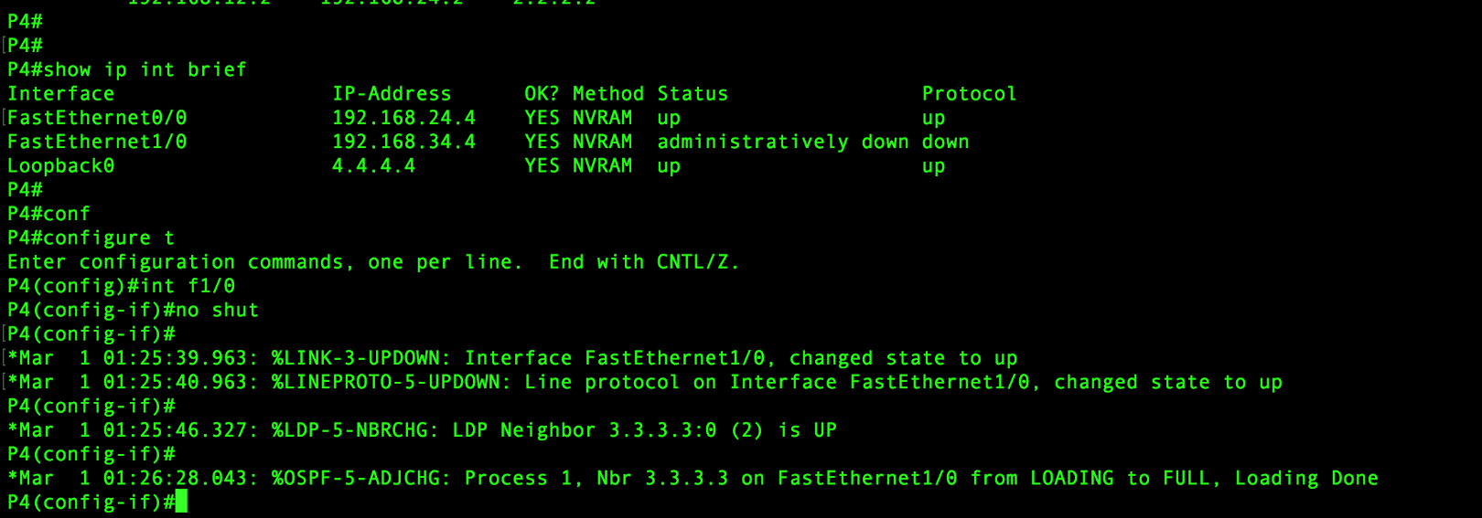

Figure 6-B: P4, IP INT

Router R3 terminal, we use the command MPLS LDP discovery transport-address interface. This will show the information about the interface that is up.

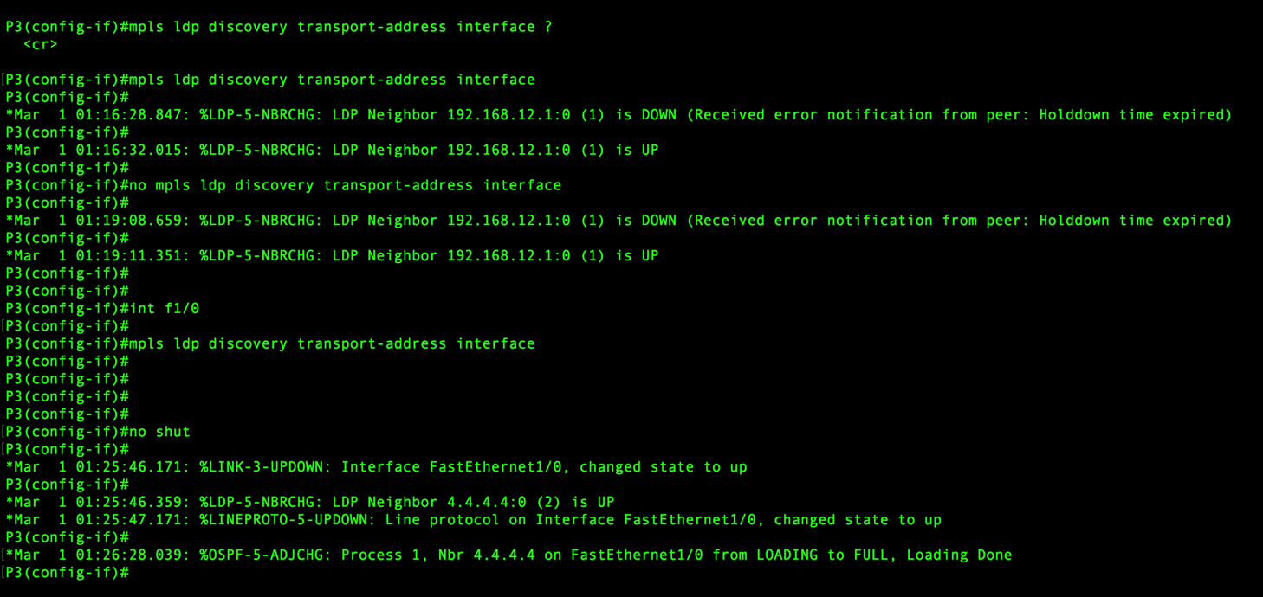

Figure 6-C: P3, Interface

## **Project Step 7:**

We configure all routers to use MPLS MD5 authentication, the password should be “VAULT”.

In this step, we use various commands like **MPLS LDP neighbor 3.3.3.3 password VAULT** and **MPLS LDP neighbor 2.2.2.2 password VAULT** in router R1. In router R2 we used, **MPLS LDP neighbor 4.4.4.4 password VAULT** and **MPLS LDP neighbor 192.168.12.1 password VAULT.**

In router R3, we used **MPLS LDP neighbor 4.4.4.4 password VAULT** and **MPLS LDP neighbor 192.168.12.1 password Vault.** In router R4, we use **MPLS LDP neighbor 2.2.2.2 password VAULT** and **MPLS LDP neighbor 3.3.3.3 password VAULT** Which means that we enable authentication between two LDP peers, which verifies each segment sent on the TCP connection between the peers. We configure authentication on both LDP peers using the same password otherwise the peer session is not established.

Authentication uses Message Digest 5(MD5) algorithm to verify the integrity of the communication and authenticate the origin of the message.

Then we used **show MPLS LDP neighbor** which displays the status of LDP sessions. Also, it gives the detailed information about the local and peer LDP Ident meaning their IP address and router ids. It also gives the information about LDP discovery sources and addresses bound to peer LDP Ident.

Similarly, we repeated the steps in R2, R3, R4.

R1 screenshot: It show MPLS LDP neighbor.

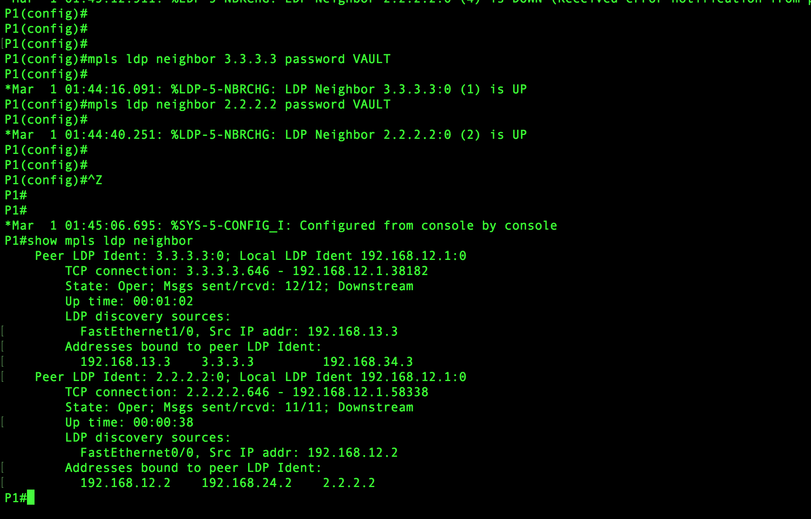

Figure 7-A: R1, MPLS LDP Neighbor

Screenshot for router R2: It shows MPLS LDP neighbor.

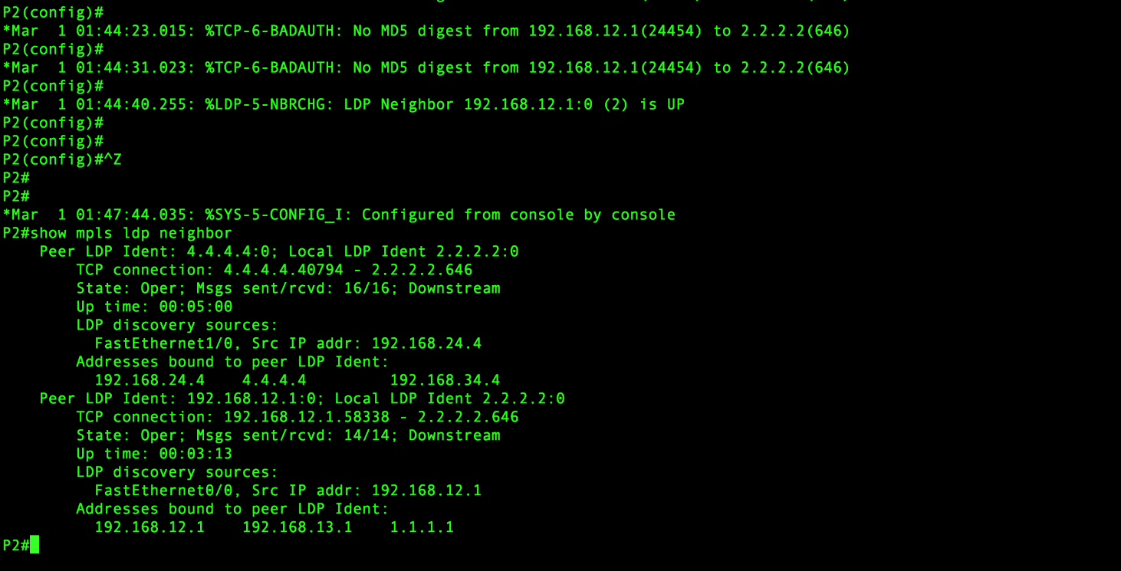

Figure 7-B: R2, MPLS LDP Neighbor

Screenshot for Router R3: It show MPLS LDP neighbor.

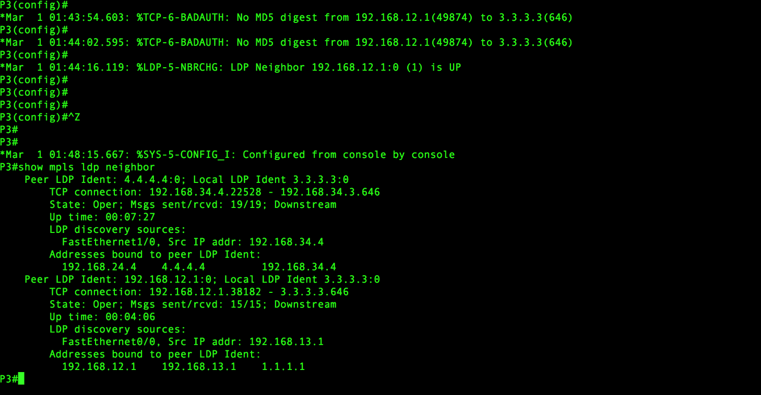

Figure 7-C: R3, MPLS LDP Neighbor

Screenshot for router R4: It show MPLS LDP neighbor.

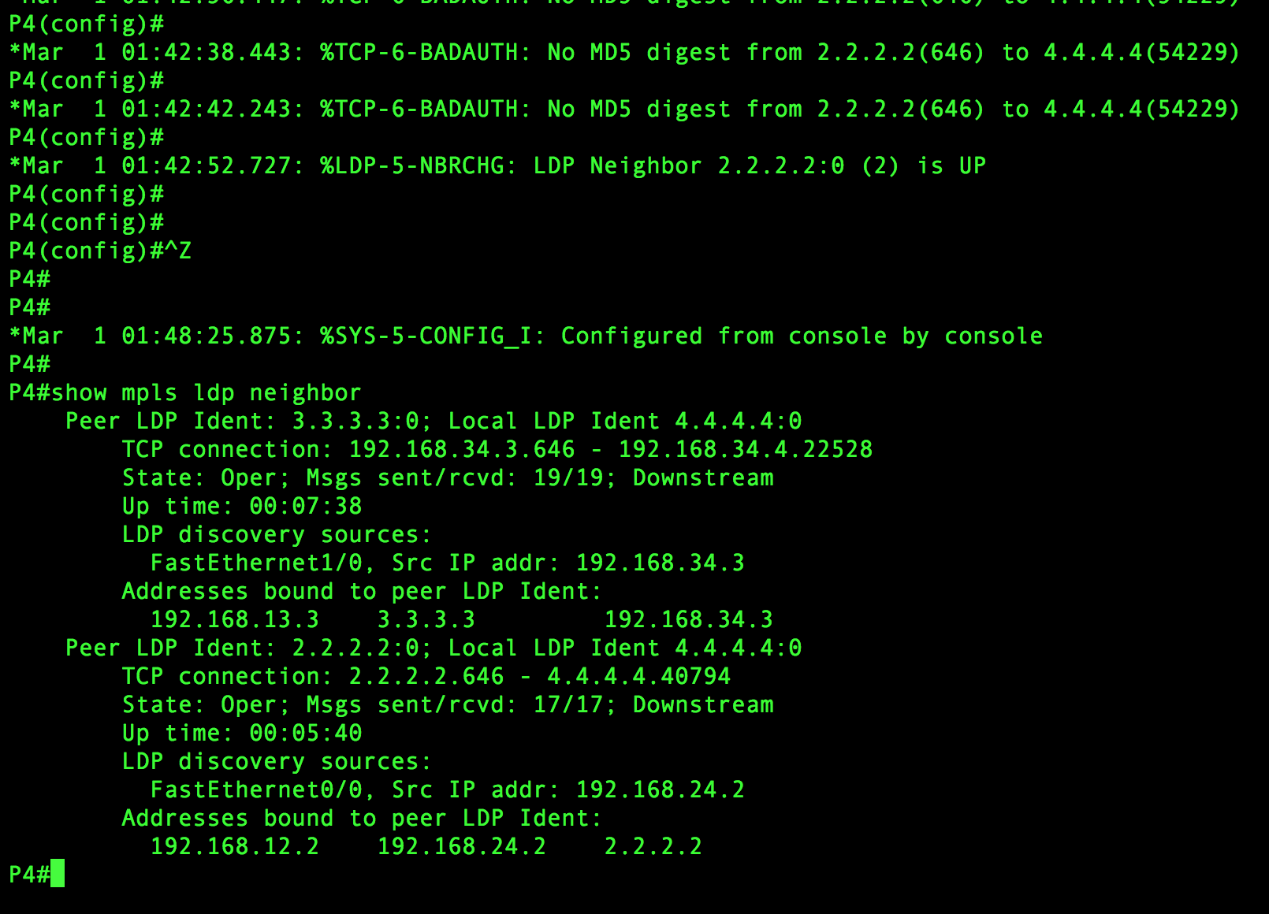

Figure 7-D: R4, MPLS LDP Neighbor

## **Project Step 8:**

The TTL from IP packets should be copied into the label on all routers.

In this step, we use command **MPLS IP propagate-TTL** in all routers. This is used to control the generation of time-to live(TTL) field in the Multiprotocol Label Switching(MPLS) header when labels are first added to an IP packet. IP TTL value is copied to MPLS TTL field during label imposition. We used tis command in all the router terminal.

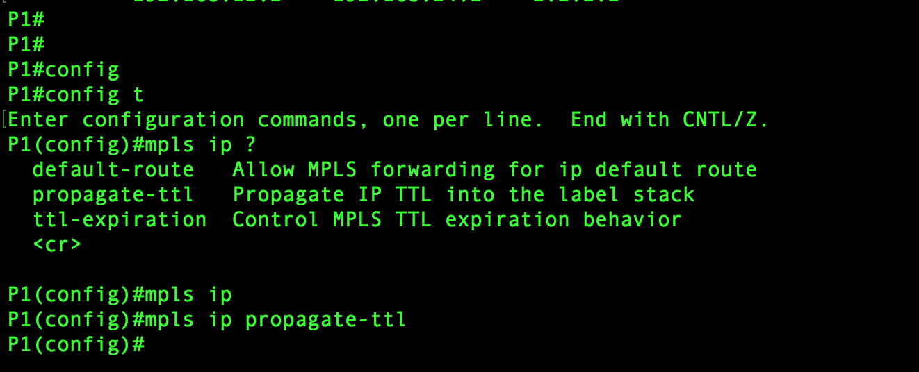

Figure 8-A: R1, MPLS IP

Similarly, we use the same command for R2, R3, R4.

## **Project Step 9:**

Advertise a default route on router R2 and make sure that there is no label advertised for the default route.

In this step, we use commands like **show IP route** which is used in router R1 to display the entire IP route table. It gives details about all the connections which are directly connected to local interface and sub-netted. For example: from screenshot, we can see that 192.168.12.0/24 is directly connected through interface F0/0 and 1.0.0.0/32 is sub-netted with I subnets.

The next command we used **is MPLS IP default route**. It is used to associate a label to a default route. It is used to enable the distribution of labels associated with the IP default route. And is used in all router terminals R1, R2, R3, R4.

Then we use another command which **is show MPLS forwarding-table** which verifies that MPLS packets are forwarded with an explicit-null label (value of 0). It gives us the information about the local tag, outgoing tag or VC, prefix or tunnel ID, bytes tag switched, outgoing interface and next hop. In table R1, we can see 16,17,18,19, 20 tags with their tunnel id and how they are going out. For example, tag 16 using pop tag goes through the tunnel id 2.2.2.2/32 and goes out through interface Fa0/0 and the next hop is 192.168.12.2 with 0 bytes’ tag switched. Tag 21 is the default route. This command is used in all router terminals R1, R2, R3, R4.

Screenshot to show IP route on terminal of R1 and MPLS IP default-route and MPLS forwarding-table are shown below: Figure 9-A: R1, Route and Table

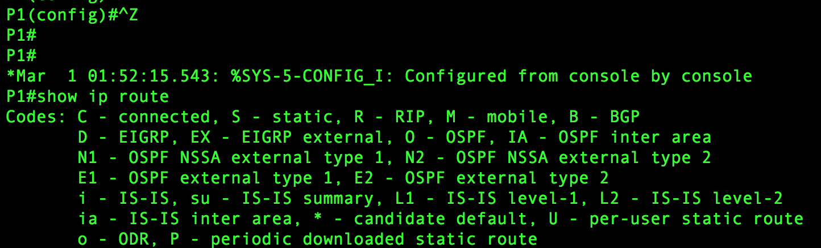

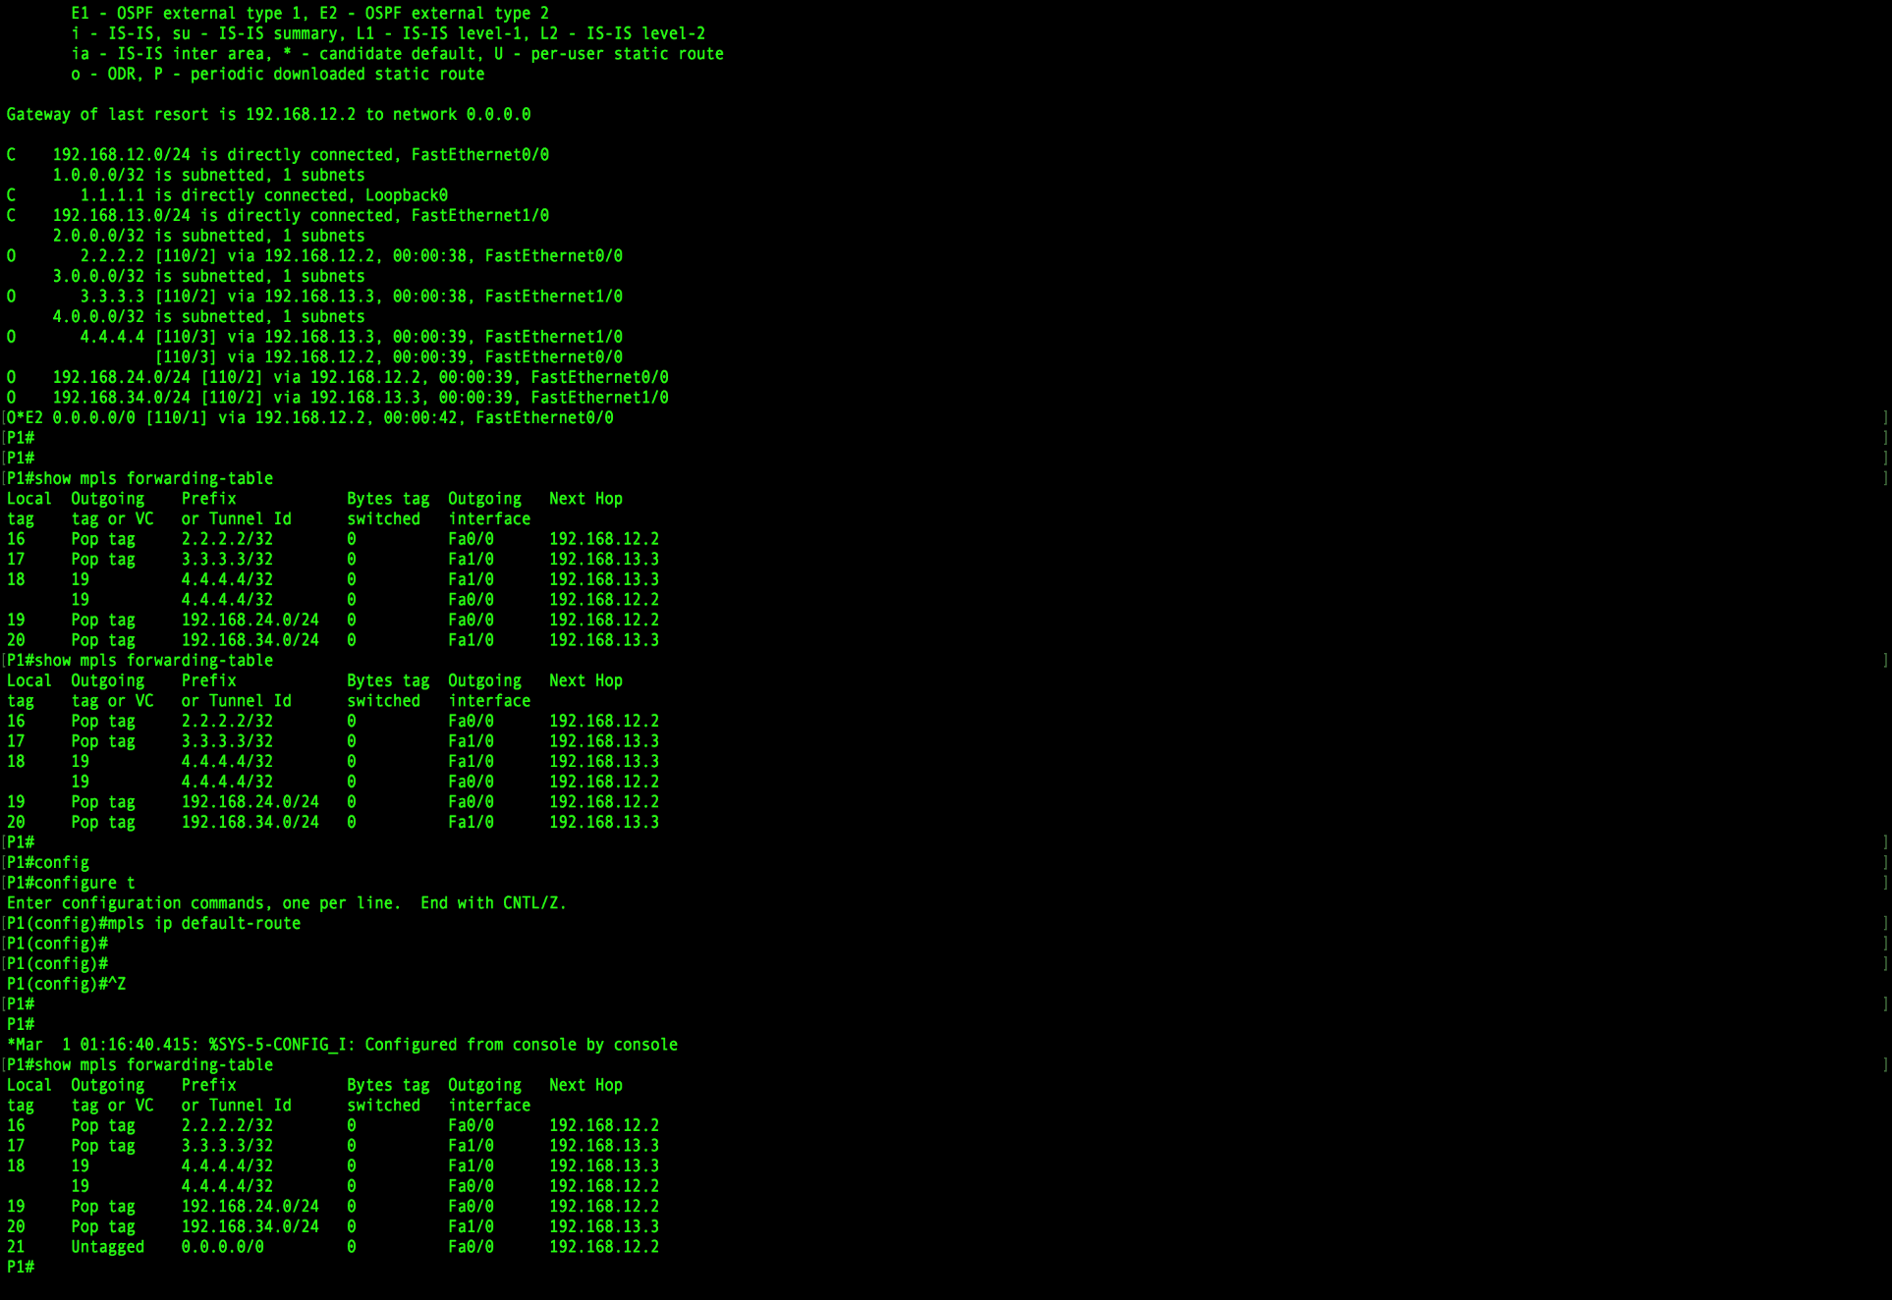

Screenshot R2: Showing MPLS IP default-route and show MPLS forwarding-table.

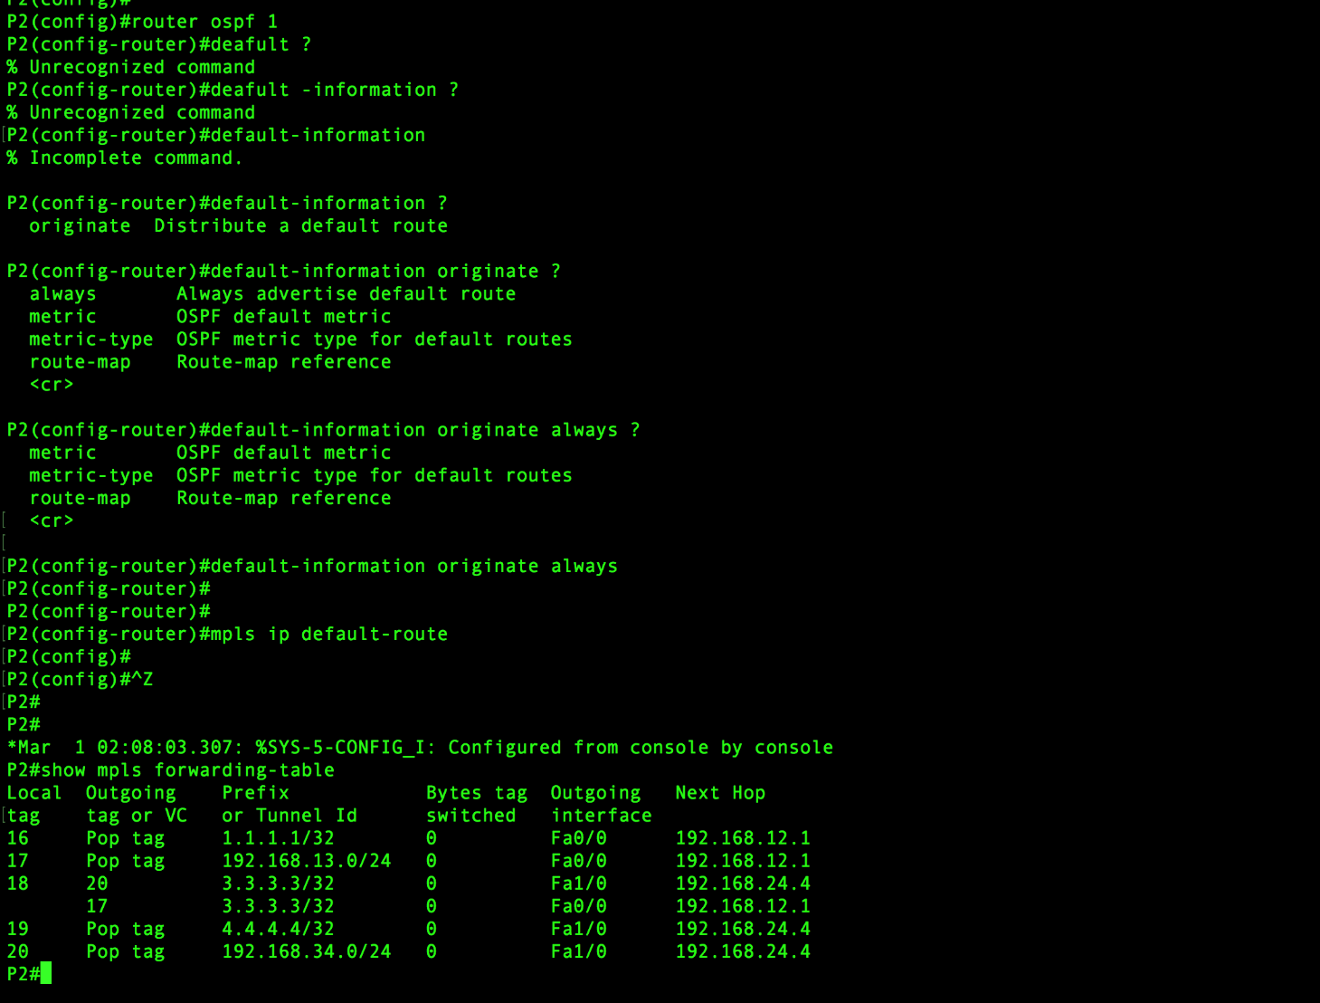

Figure 9-B: R2, Route and Table

Screenshot R3: Showing MPLS IP-default-route and show MPLS forwarding-table

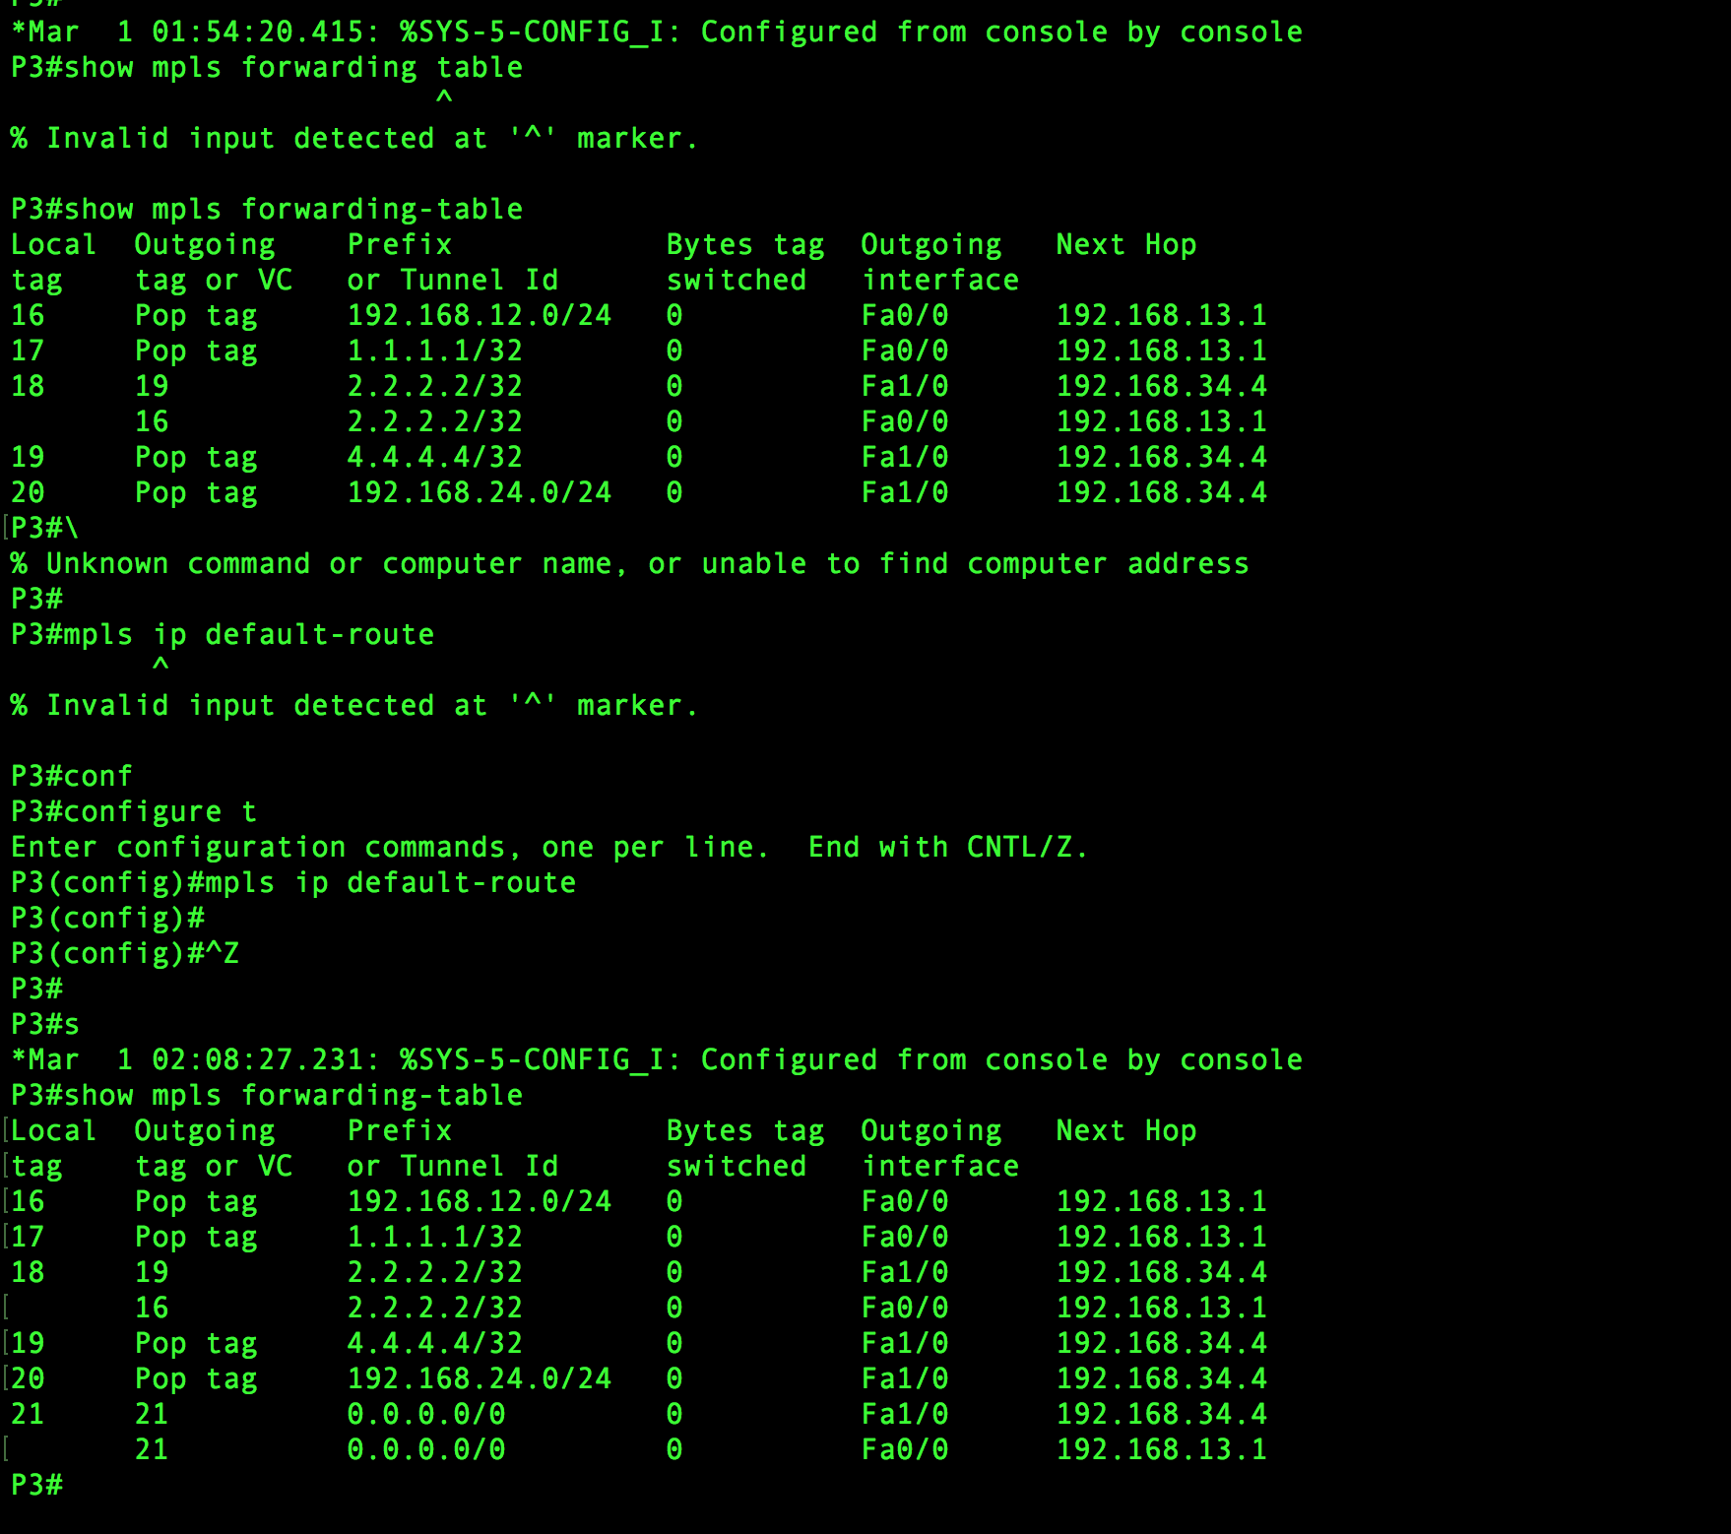

Figure 9-C: R3, Route and Table

Screenshot for R4: Showing MPLS IP-default-route and show MPLS forwarding-table 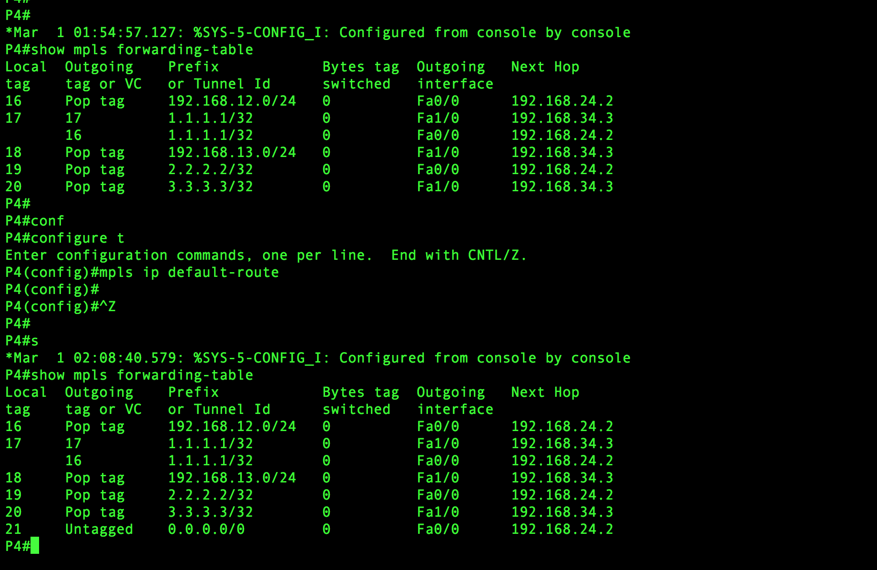

Figure 9-D: R4, Route and Table

## **Labels assigned between each pair of attached LSR:**

**For router R1:**

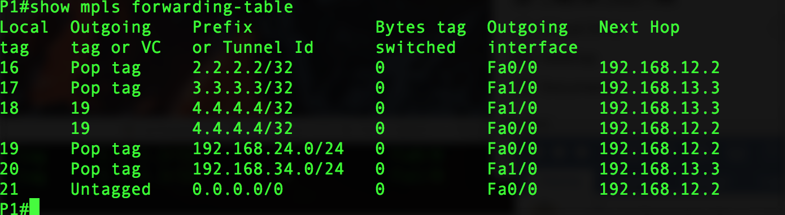

Description about how labels are assigned: We can see in the above screenshot that R1 uses label 16 to connect to R2 whose address is 2.2.2.2/32 by using the interface F0/0 and 192.168.12.2, the next hop and after reaching R2 it pops the packet. It uses label 17 to connect to R3 whose address is 3.3.3.3/32 by using the interface 192.168.13.3, the next hop and after reaching R3 it pops the packet. It uses label 18 to connect to R4 whose address is 4.4.4.4/32 by using either R2 or R3 interface address. The label is swapped from 18(which is assigned in prior) to 19 which is assigned at R3 and from R3, it is sent to R4 using label 20. The label is swapped from 18(which is assigned in prior) to 19 which is assigned at R2 and from R2, it is sent to R4 using label 19. This is popped out and at egress R4.

**For router R2:**

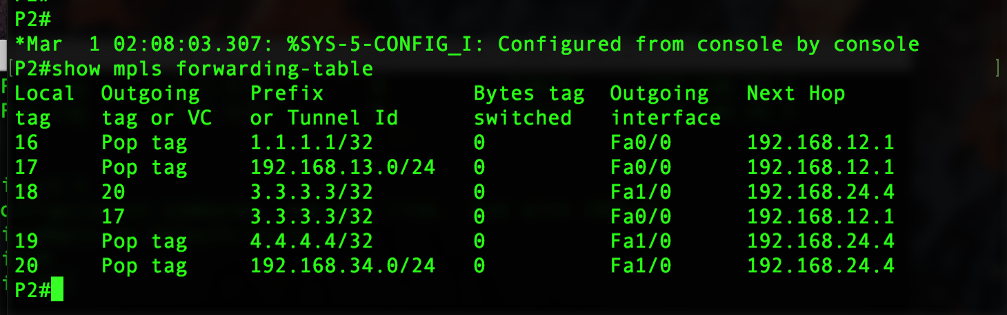

Description about how labels are assigned: We can see in the above screenshot that R2 uses label 16 to connect to R1 whose address is 1.1.1.1/32 by using the interface F0/0 and 192.168.12.1, the next hop and after reaching R1 it pops the packet.it uses label 19 to connect to R4 whose address is 4.4.4.4/32 by using the interface F0/0 and 192.168.24.4, the next hop and after reaching R4 it pops the packet out. It uses label 17 to connect to R3 whose address is 192.168.13.0/24 by using the interface F0/0and 192.168.12.1, the next hop and after reaching R3 it pops the packet. It uses label 18 to connect to R3 whose address is 3.3.3.3 by using either R1 or R4 interface address. The label is swapped from 18(which is assigned in prior) to 20 which is assigned at R4 and from R4, it is sent to R4 using label 20. The label is swapped from 18(which is assigned in prior) to 20 which is assigned at R4 and from R3, it is sent to R4 using label 17. This is popped out and at egress R4.

**For router R3:**

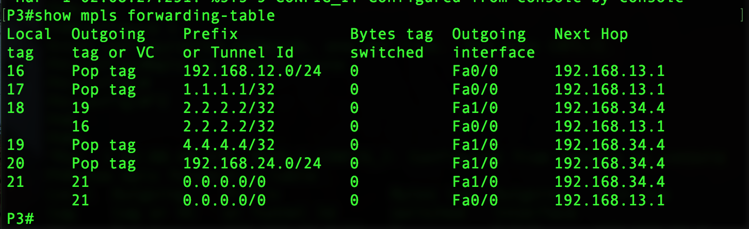

Description about how labels are assigned: We can see in the above screenshot that R3 uses label 17 to connect to R1 whose address is 1.1.1.1/32 by using the interface F0/0 and 192.168.13.1, the next hop and after reaching R1 it pops the packet.it uses label 19 to connect to R4 whose address is 4.4.4.4/32 by using interface and 192.168.34.4, the next hop and after reaching R4 it pops the packet out. It uses label 18 to connect to R2 whose address is 2.2.2.2/32 by using either R4 and R1 interface address, the next hop and after reaching R2 it pops the packet. The label is swapped from 18 to 19 which is assigned to R4 and from R4, it is sent to R2 and pops the packet out. The label is swapped from 18 to 16 which is assigned to R1anf from R1it reaches R3. it uses label 20 to send packets from R2 to R4 This is popped out and at egress R2.

**For router R4:**

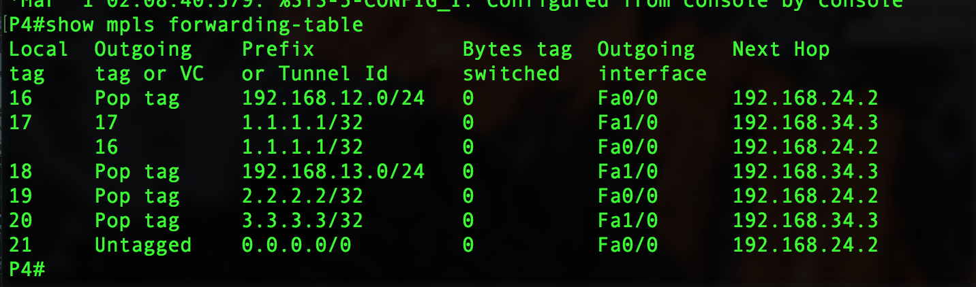

Description about how labels are assigned: We can see in the above screenshot that R4 uses label 19 to connect to R2 whose address is 2.2.2.2/32 by using the interface 192.168.24.2, the next hop and after reaching R2 it pops the packet.it uses the label 20 to connect to R3 whose address is 3.3.3.3/32 by using the interface 192.168.34.3, the next hop and after reaching R3 it pops the packet.it uses label 17 to connect to R1 whose address is 1.1.1.1/32 by using either R2 or R3 interface address. The label is swapped from 17(which is assigned in prior) to 16 which is assigned to R2 and from R2, it is sent to R1 using label. The label is swapped from 17(which is assigned in prior) to 18 which is assigned to R2, it is sent to R4 using label 18. This is popped out at egress R1.

## --- END OF PROJECT REPORT ---